Application Form

Checklist of documents to be submitted to the ATSAF Academy

Cover letter signed by the applicant, including a motivation statement

Application form

Curriculum vitae, signed and dated in tabular form (one page)

MSc certificate and transcript of academic records issued by the examination office

TOEFL or IELTS certificate or other English proficiency certificate

Letter of recommendation and supervision commitment from a German university professor (thesis supervisor) - please use the provided form

Letter of recommendation and supervision commitment from a CGIAR++ centre scientist (thesis supervisor), stating the attachment to a CGIAR++ research project - please use the provided form

Hosting Agreement from the respective CGIAR++ centre - please use the provided form. If the provided form cannot be used after all, please ensure, that the meaning of the statement in the provided form is retained in the form you use.

Please convert documents 1 to 5 (in this sequence) into one PDF file and send your application in one e-mail to academy@atsaf.de.
Please name the file in a systematic way: <applicant’s last name – year – application ATSAF Academy>, (e.g. Smith-2021-application ATSAF Academy). To transform the documents into PDF one can download “FreePDF” as freeware.
Documents 6 to 8 have to be sent by respective supervisor.
Application must be complete before being considered for further selection process.

We wish you all the best for your application!

- Personal Data

Name of the applicant (as indicated in the passport)

Last name:

First name:

Middle name:

Date of Birth (day/month/year):

Place of Birth:

Nationality:

Place of living:

Postal address:

Mobile:

E-mail:

Gender:

Private (residential) address:

Telephone:

- Title of Diploma or Master thesis and submitted to which university: (Please tick as appropriate)
Thesis title:
Submitted to:

- Abstract of Diploma or Master thesis:
(Maximum 300 words)

- Please list max 5 publications/ conference contributions if applicable:

- Language / English Proficiency

First language:
Language(s) used as medium of instruction in secondary school:

Language(s) used as medium of instruction in higher education:

language(s) skills (please indicate the level according to the figure below):

Foreign applicants: In order to get the admission of the faculty for PhD student you must provide proof that the medium of instruction at your school or university was English, or a certified statement from a recognized authority (e.g. TOEFL: 550, IELTS: 6, British Council) concerning your proficiency in English. You can hand in this proof later in case you are selected for the ATSAF Academy scholarship. If you cannot verify adequate English language skills, you cannot get the admission by the faculty and your ATSAF Academy scholarship cannot be awarded.

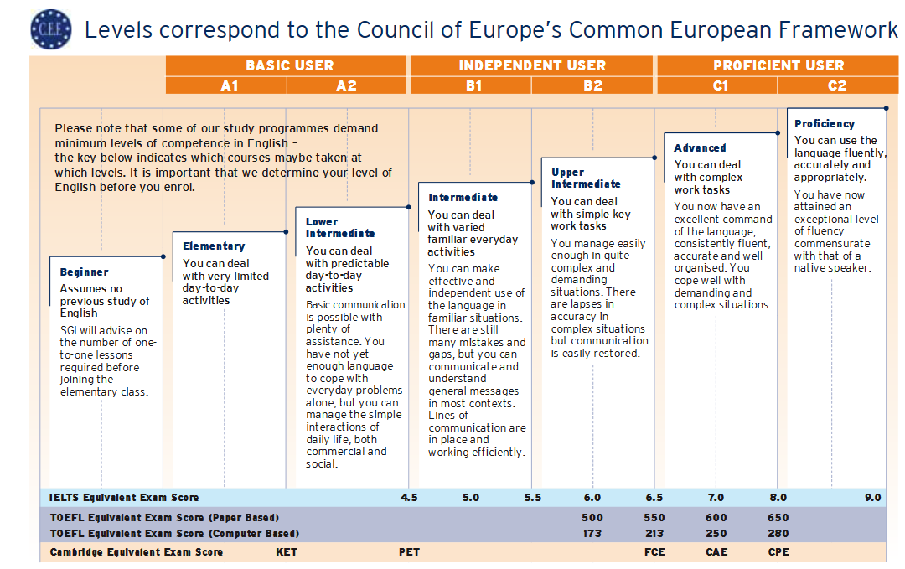

- Research proposal

Title of your proposal:
Summary:
(give a brief summary of your research proposal, maximum 250 words)
Introduction:
(Maximum 300 words)
Objective and research questions:
(Maximum 200 words)
Methodology:
(Maximum 300 words)
Expected results:
(Maximum 200 words)
Work plan:
(please give a monthly schedule of your activities during your PhD program – narrative and Grantt - chart)
Thematic link to development oriented agricultural research:
(Maximum 200 words)
Thematic link to the hosting CGIAR++ research project:
(Maximum 200 words)
Estimated budget:
- Please provide the detailed description along with full calculations of your proposed budget (EUR) of the project (categories: personnel, consumables, equipment, travel, publications and conferences). Please specify the items belonging to categories. Your scholarship should be calculated as 36 months x 1500 EUR.
- Indicate and specify the amount in EUR of the proposed budget you require from the ATSAF Academy in addition to your scholarship (use the categories above).
References:

I do hereby confirm that the information provided above is correct to my knowledge.

Place and date | Signature

